Diocese of Dallas
Bishop’s Annual Appeal
2025 Social Media Guide

Category | Date | Topic | Graphic | Post Copy / Description
Social Media | Week of Jan. 19 | Evergreen Post  (Bishop) | 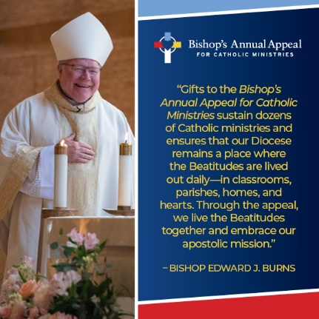 | Through the Bishop’s Annual Appeal for Catholic Ministries, we live the Beatitudes together and embrace our apostolic mission.  Gifts to the Bishop’s Annual Appeal support Catholic ministries across the Diocese of Dallas. To learn more about the Appeal, visit https://dallasbishopsappeal.com/.
Social Media | Week of Jan. 19 |  | 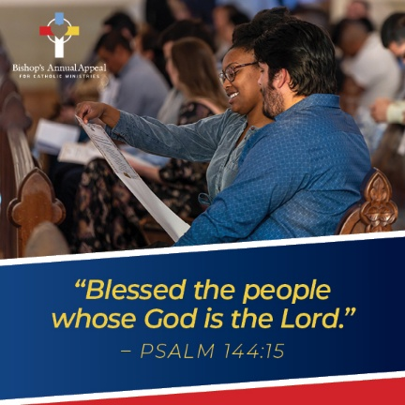 | Donors to the Bishop’s Annual Appeal for Catholic Ministries play an important part of keeping the Catholic faith alive and flourishing in our Diocese with their generosity and prayers, giving hope to those who need it most.  To learn more about the Appeal and the Catholic ministries it supports, visit https://dallasbishopsappeal.com/.
Event | Jan 25-26 | Advance Weekend
Social Media | Week of Jan. 26 | Evergreen Post  (seminarians) | 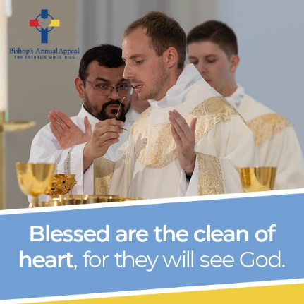 | Did you know that by supporting the Bishop’s Annual Appeal you are directly funding faith formation and education of seminarians in the Diocese of Dallas? Each year, more than $2 million is distributed for seminarian education at Holy Trinity Seminary and Redemptoris Mater Seminary.  To support seminarians and so many other Catholic ministries, you can make a gift at https://donate.dallasbishopsappeal.com/!
Social Media | Week of Jan. 26 | BAA Appeal Video | Link to Appeal Video | COPY TBD BASED ON VIDEO  We invite you to prayerfully consider supporting the appeal this year with a monthly gift or a one-time donation. To make your gift, visit: donate.dallasbishopsappeal.com.
Event | Jan 31-Feb 1 | Commitment Weekend
Social Media | Week of Feb. 2 | Evergreen Post  (Youth and Young Adults) |  | In the Diocese of Dallas, Youth and Young Adult Ministries create spaces where young people are known, welcomed, and formed as disciples of Christ. From retreats and conferences like The635 to small groups, campus ministry, service projects, and mentorship, these ministries walk with young people as they grow in faith, leadership, and community. Because of your generosity to the Bishop’s Annual Appeal, our youth and young adults are never alone on their journey. Thank you for investing in the future of our Church!  To learn more about the Bishop’s Annual Appeal or make a gift, visit https://dallasbishopsappeal.com/.
Social Media | Week of Feb. 2 | Evergreen Post  (pastoral services) | 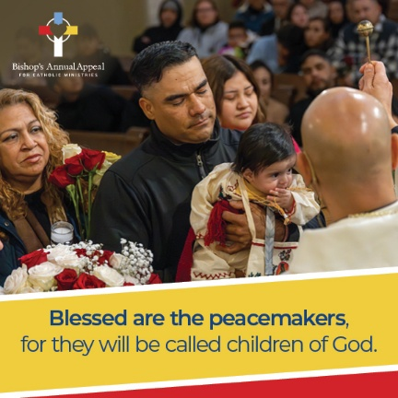 | Throughout the Diocese of Dallas, pastoral ministries walk alongside parishioners, offering spiritual nourishment and guidance. Sacraments, counseling, mission work, mental health first aid, homebound ministry and other important support groups, ensure no one journeys alone. These ministries all receive funding through the Bishop’s Annual Appeal because of your generosity. Thank you for your support of those most in need in our community!  To learn more about the Bishop’s Annual Appeal or make a gift, visit https://dallasbishopsappeal.com/.
Event | Feb 7-8 | Follow-up Weekend
Social Media | Week of Feb. 9 | Evergreen Post (Catholic Schools) | 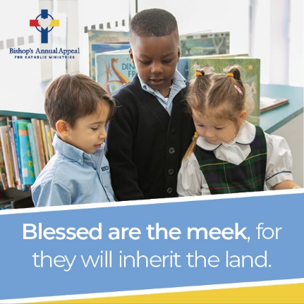 | Catholic schools form young disciples in faith, knowledge, and virtue. In classrooms rooted in the Gospel, students are nurtured academically, spiritually, and morally. Through the Bishop Annual Appeal, Catholic education remains accessible and strong for families across our community. Thank you for supporting our schools and investing in the future of the Church.  To learn more about the Bishop’s Annual Appeal and make a gift to support Catholic Schools in the Diocese, visit: https://dallasbishopsappeal.com/.
Social Media | Week of Feb. 9 | Evergreen Post (thank you post) | 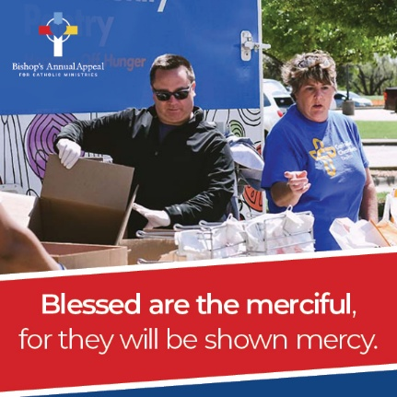 | More than #### families have already made a commitment to the 2026 Bishop’s Annual Appeal—THANK YOU!  Your generosity makes a difference in our community, from seminarians to job seekers to young families to retired priests and so many others.  Please complete a commitment form in your parish or visit https://donate.dallasbishopsappeal.com/ to make a safe, secure and online gift today!

