Diocese of Dallas
Bishop’s Annual Appeal
2025 Social Media Guide

Category | Date | Topic | Graphic | Post Copy / Description
Social Media | Week of Jan. 20 | Evergreen Post  (Bishop) | 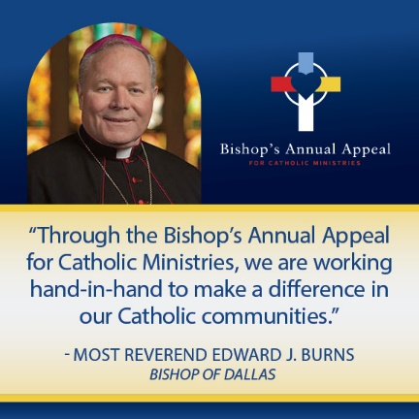 | Through the Bishop’s Annual Appeal, tens of thousands of Catholics from across our diocese come together to invest in our Catholic community. Together, we support parishes and schools throughout the Diocese. We care for our retired priests and invest in our young seminarians. We provide food for the hungry and shelter for the homeless. With apostolic zeal we go out into the world to transform it, spreading the message of Jesus to the ends of the Earth.  To learn more about the Bishop’s Annual Appeal, visit https://dallasbishopsappeal.com/.
Social Media | Week of Jan. 20 |  | 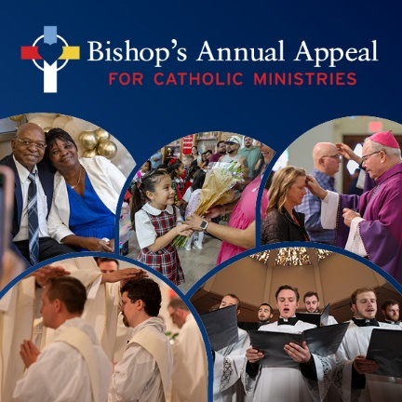 | Donors to the Bishop’s Annual Appeal for Catholic Ministries play an important part of keeping the Catholic faith alive and flourishing in our Diocese with their generosity and prayers, giving hope to those who need it most.  Gifts to the Bishop’s Annual Appeal support our Church family and Catholic ministries across the Diocese of Dallas. To learn more about the Appeal, visit https://dallasbishopsappeal.com/.
Event | Jan 25-26 | Advance Weekend
Social Media | Week of Jan. 27 | Evergreen Post  (seminarians) | 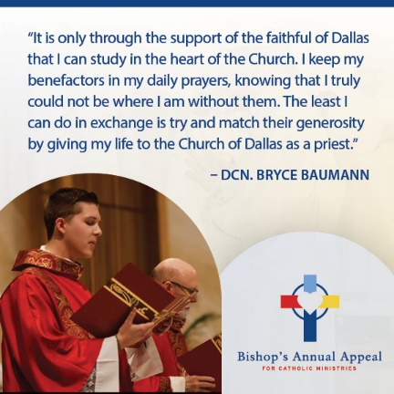 | Did you know that by supporting the Bishop’s Annual Appeal you are directly funding faith formation and education of seminarians in the Diocese of Dallas? Each year, more than $2 million is distributed for seminarian education at Holy Trinity Seminary and Redemptoris Mater Seminary.  To support seminarians like Dcn. Baumann, you can make a gift at https://donate.dallasbishopsappeal.com/!
Social Media | Week of Jan. 27 | BAA Appeal Video | Link to Appeal Video | Through the Bishop’s Annual Appeal, we support more than 26 ministries that serve 1.4 million Catholics, empowering us to live out our apostolic mission daily.  Each ministry we support helps create a rich tapestry of faith across our diocese. Let us continue this mission together, proclaiming the Gospel and building up the Kingdom of God.  We invite you to prayerfully consider supporting the appeal this year with a monthly gift or a one-time donation. To make your gift, visit: donate.dallasbishopsappeal.com.
Event | Feb. 1-2 | Commitment Weekend
Social Media | Week of Feb. 3 | Evergreen Post  (Youth and Young Adults) | 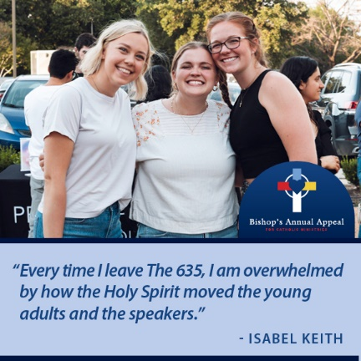 | Through outreach programs in the Diocese of Dallas, we answer Christ’s call to serve others. Our youth and campus ministries, like The 635, are bringing young people closer to Christ, with hundreds gathering at each event to deepen their faith.  To learn more about the Bishop’s Annual Appeal and make a gift to support Catholic Schools in the Diocese, visit: https://dallasbishopsappeal.com/.
Social Media | Week of Feb. 3 | Evergreen Post  (pastoral services) | 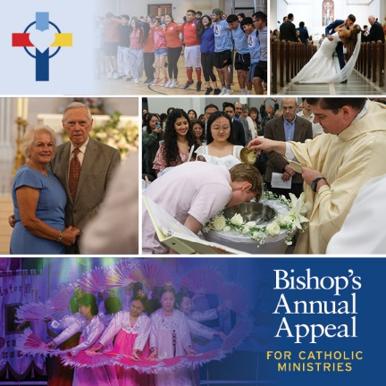 | Throughout the Diocese of Dallas, pastoral ministries walk alongside parishioners, offering spiritual nourishment and guidance. Sacraments, counseling, mission work, mental health first aid, homebound ministry and other important support groups, ensure no one journeys alone. These ministries all receive funding through the Bishop’s Annual Appeal because of YOU. Thank you for your support of those most in need in our community.  To learn more about the Bishop’s Annual Appeal or make a gift, visit https://dallasbishopsappeal.com/.
Event | Feb 8-9 | Follow-up Weekend
Social Media | Week of Feb. 10 | Evergreen Post (thank you post) | 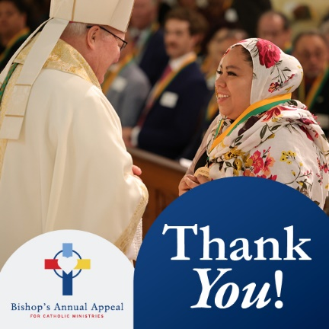 | More than #### families have already made a commitment to the 2025 Bishop’s Annual Appeal—THANK YOU!  Your generosity makes a difference in our community, from seminarians to job seekers to young families to retired priests and so many others.  Please complete a commitment form in your parish or visit https://donate.dallasbishopsappeal.com/ to make a safe, secure and online gift today!

